**Hello Team!** **Consider the below two tables**:

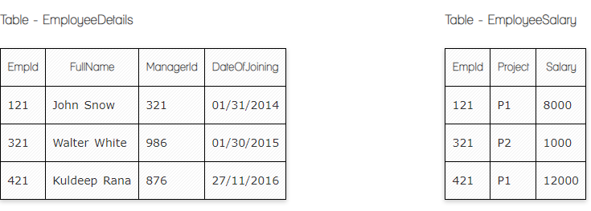

**Ques.1. Write a SQL query to fetch the count of employees working in project 'P1'.**

**Your Answer:**

Select count (*)

From EmployeeSalary

Where project = ‘P1’

**Ques.2. Write a SQL query to fetch employee names having salary greater than or equal to 5000 and less than or equal 10000.**

**Your Answer:**

Select FullName

From EmployeeDetails

Where EmpId

(Select EmpId

From EmployeeSalary

Where salary between 5000 and 10000)

**Ques.3. Write a SQL query to fetch count of employees sorted by project's count in descending order.**

**Your Answer:**

Select Project, count (EmpId) EmpCount

From EmployeeSalary

Group by Project

Order by EmpCount desc

**Ques.4. Write a query to fetch employee names and salary records. Return employee details even if the salary record is not present for the employee.**

**Your Answer:**

Select FullName, Salary

From EmployeeDetails

Left Join EmployeeSalary

On EmployeeDetails.FullName= EmployeeSalary.Salary